U8
Autumn and Winter Menu Week 1
 | Breakfast | Morning Snack | Lunch | Lunch (vegetarian option) | Afternoon Snack | Tea
Monday | Choice of cereals  banana and toast  ^{D, G, SO}  , | Cheddar cheese and cream crackers  ^{D, G} | Vegetable and chickpea korma with rice and seasonal vegetables  ^{D, G}  Yogurt and compote fruit ^{D} |  | Clementine | Potato wedges and bean dip  Fresh fruit
Tuesday | Choice of cereals  ^{D, G}  toast, ^{G}  and pineapple | Pear | Haddock and vegetable pasta bake served with green beans. ^{G}  Melon and pineapple | Butter bean and leek pasta bake served with broccoli D, G | Beetroot Hummus and Rice Cakes | Savoury onion and chive scone with bean dip ^{D, G}  Fresh fruit
Wednesday | Choice of cereals  ^{D, G}  cheese, cucumber and toast D, G, SO | Bean dip and  Water Biscuits  ^{D, G} | Lamb and apricot stew served with couscous G.  Apple and raisin strudel G | Kidney beans and apricot stew served with couscous, G, | Apple | Lentil and carrot soup with bread ^{D, G}  Fresh fruit
Thursday | Choice of cereals  ^{D, G}  ^{kiwi and crumpet G, SO} | Melon | Chicken and mushroom casserole with mashed potato and vegetables,  ^{Yogurt and mixed berries D} | Pinto beans and mushroom served with mashed potato and vegetables D | Hummus and Bread Sticks,  ^{G, SE} | Sandwiches served.  with salad ^{D, D, F, G, SO}  Fresh fruit
Friday | Choice of cereals  ^{D, G}  Homemade cinnamon bread and apple^{, G} | Cream cheese  and Corn Cakes  ^{D} | Lentil and vegetable bolognaise served with pasta and steamed cabbage D, G,  Semolina and date pudding ^{D, G} |  | Kiwi | Cheese and tomato pizza served with salad ^{D, G}  Fresh fruit

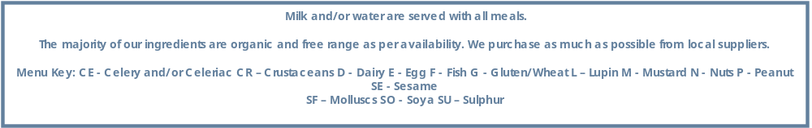

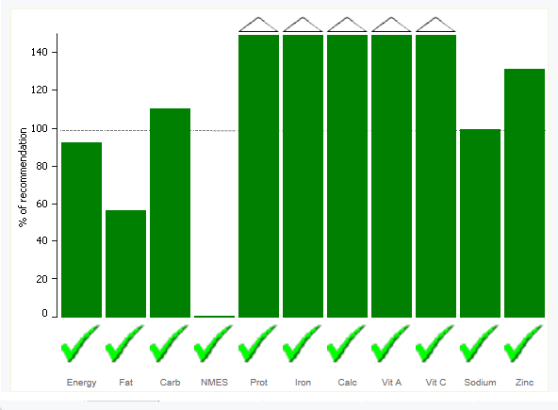
 | Breakfast | Morning Snack | Lunch | Lunch (vegetarian option) | Afternoon Snack | Tea
Monday | Choice of cereals  Peach and toast  ^{D, G, SO}  , | Red Leicester Cheese and Corn cakes  ^{D, G} | Mixed bean and vegetable pasta bake  ^{D, G}  Yogurt and fruit ^{D,} |  | Apple | Sandwiches served with salad  ^{D, G,F SO}  Fresh fruit
Tuesday | Choice of cereals  ^{D, G}  toast, ^{G}  pineapple, and cheese | Pear | Chicken, basil and tomato served with rice  Fruity vegan jelly | Paneer, basil and tomato served with rice  ^{D, G} | Carrot hummus and water biscuit | Mixed vegetable soup with bread ^{SO, G}  Fresh fruit
Wednesday | Choice of cereals  ^{D, G}  Homemade mixed fruit loaf and mango G, | Cream cheese with chive and bread sticks  ^{D, G,SE} | Lentil and vegetable pie with sweet potato topping served Cauliflower D, G  Melon | Lentil and vegetable pie with sweet potato topping served Cauliflower D, G  Melon | Clementine | Chicken(chickpea)t tortilla with carrot and cucumber ^{D, G}  Fresh fruit
Thursday | Choice of cereals  ^{D, G}  Cream cheese crumpet and berry G, SO | Melon | Haddock and squash tagine served with couscous  ^{Apricot and custard s D} | Tofu and squash tagine served with couscous | Tzatziki dip and rice cake  ^{,D} | Homemade baked beans served.  With bread,^{, G, SO}  Fresh fruit
Friday | Choice of cereals  ^{D, G}  Toast and grapes ^{G} | Bean dip  and Cracker  ^{D} | Beef keema(lentil) served with rice and steamed cabbage  Banana |  | Kiwi | Macaroni cheese corn bake ^{G. D}  Fresh fruit

Autumn and Winter Menu Week 2

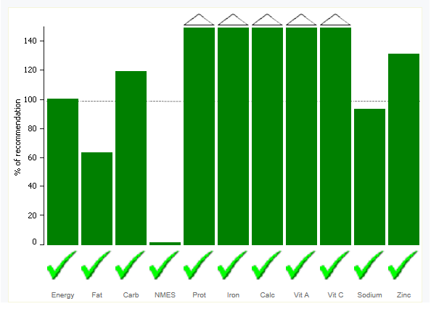

F
Autumn and Winter Menu week 3
 | Breakfast | Morning Snack | Lunch | Lunch (vegetarian option) | Afternoon Snack | Tea
Monday | Choice of cereals  ^{D, G}  ^{Banana and toast D, G, SO} | Edam and Rice Cakes  ^{D} | Mushroom and pea pasta alfredo served with green beans D, G  ^{Clementine} |  | Pear | Cheese and beans on toast with salad ^{D, G}  Fresh fruit
Tuesday | Choice of cereals  ^{D, G and Crumpet and peach G} | Kiwi | Creamy chicken and pesto potato bake  Custard with fruit | Creamy butter bean and pesto potato bake | Tzatziki dip and Bread Sticks  ^{D, G} | Carrot and coriander soup with bread. ^{D, G}  Fresh fruit
Wednesday | Choice of cereals ^{D, G}  Homemade rosemary bread  and  cucumber | Cream cheese and Wholemeal pitta  ^{D, G} | Salmon and mixed vegetable kedgeree ^{F}  ^{Yogurt and Fruit puree D} | Paneer and mixed vegetable kedgeree ^{D} | Banana | Sandwiches  Served with salad, ^{D, F, G, SO}  Fresh fruit
Thursday | Choice of cereals  ^{D, G}  ^{Cheese, pear, and toast G, SO} | Pineapple | Mixed bean goulash served with couscous ^{D, G}  Banana |  | Bean dip and Cream Crackers  ^{D, G} | Chicken and mixed pepper pizza (hummus) served with salad  Fresh fruit
Friday | Choice of cereals ^{D, G}  Clementine and toast, ^{D, G, SO} | Minty pea dip and water biscuit  ^{D, G} | Beef and mushroom stroganoff with pasta and broccoli ^{D, G}  Rice pudding and fruit compote ^{D, G} | Puy lentil and mushroom stroganoff with pasta ^{D, G} | Blueberry | Taco Friday  .  Fresh fruit. ^{, D,E,G}

Autumn and Winter Menu week 4
 | Breakfast | Morning Snack | Lunch | Lunch (vegetarian option) | Afternoon Snack | Tea
Monday | Choice of cereals ^{D, G}  Pear and toast  ^{G, SO} | Red Leicester and Wholemeal Rice Cakes  ^{D} | Chickpea and vegetable tagine with couscous  ^{D, G}  Banana |  | Apple | Tuna and vegetable pasta bake ^{D, F, G}  Fresh fruits
Tuesday | Choice of cereals ^{D, G}  Toast and mango ^{D, G} | Clementine | Sweet potato and squash curry served with rice ^{D, G}  Seasonal fruit salad |  | Beetroot Hummus and Corn Cakes | Minty pea soup  With naan ^{D, G}  o Fresh fruits  s F
Wednesday | Choice of cereals ^{D, G}  Toast and ^{G, SO}  berry | Cottage cheese and chive dip with corn cakes | One pan Spanish cod stew with flat bread ^{D, G}  Mixed berry smoothie ^{D,} | One pan Spanish edamame stew with flat bread ^{G, SO} | Melon | Beef (Lentil) onion wrap with salad ^{D, G}  Fresh fruits
Thursday | Choice of cereals ^{D, G}  Homemade mixed fruit loaf and banana ^{G} | Pear | Beef hotpot with mash potato with mixed vegetables  Stewed apple and custard ^{D,} | Kidney bean and onion hotpot with mash potato with mixed vegetables | Minty yogurt and bread stick^{, G,D} | Cheese and beans on toast with salad ^{D, G}  Fresh fruits
Friday | Choice of cereals ^{D, G}  Grapes and toast ^{G, SO} | Bean dip and cream crackers | chicken and pesto pasta with pea D, G  ^{fruity vegetarian jelly} | Tofu and pesto pasta with pea D, G, SO | ^{Banana} | Pitta bread with cheese, hummus and salad  Fresh fruit ^{D, F}

Sunshine/Lilac Autumn & winter 1
 | Stage | Breakfast | Lunch | Tea
Monday | Weaning | Formula, baby rice, cereal | Courgette puree | Apple
Monday | Introducing to protein | Choice of cereals  ^{D, G} | Courgette and green beans puree with mashed chickpea | Apple and apricot puree
Tuesday | Weaning | Formula, baby rice, cereal | Cauliflower puree | Banana
Tuesday | Introducing to protein | Choice of cereals  ^{D, G} | Cauliflower and broccoli puree with flake haddock | Banana and pineapple puree
Wednesday | Weaning | Formula, baby rice, cereal | Butternut squash puree | Pear
Wednesday | Introducing to protein | Choice of cereals  ^{D, G} | Butternut squash and parsnip puree with mince beef | Pear and mango puree
Thursday | Weaning | Formula, baby rice, cereal | Potato puree | Strawberry
Thursday | Introducing to protein | Choice of cereals  ^{D, G} | Potato and turnip puree with mince chicken | Apple and strawberry puree
Friday | Weaning | Formula, baby rice, cereal | Carrot puree | Mango
Friday | Introducing to protein | Choice of cereals  ^{D, G} | Carrot and cabbage puree with lentil G | Mango and peach puree

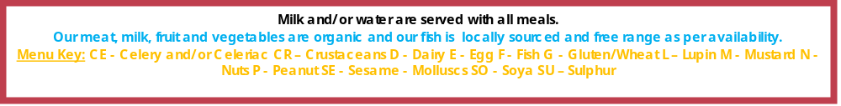

Sunshine /Lilac Autumn &winter 2
 | Stage | Breakfast | Lunch | Tea
Monday | Weaning | Formula, baby rice, cereal | Pea puree | Pear
Monday | Introducing to protein | Choice of cereals  ^{D, G} | Pea and red pepper puree with mashed beans | Pear and pineapple puree
Tuesday | Weaning | Formula, baby rice, cereal | Carrot puree | Apple
Tuesday | Introducing to protein | Choice of cereals  ^{D, G} | Carrot and courgette puree with mince chicken | Apple and melon puree
Wednesday | Weaning | Formula, baby rice, cereal | Sweet potato puree | Banana
Wednesday | Introducing to protein | Choice of cereals  ^{D, G} | Sweet potato and green beans puree with mashed lentil | Banana and strawberry puree
Thursday | Weaning | Formula, baby rice, cereal | Butternut squash puree | Mango
Thursday | Introducing to protein | Choice of cereals  ^{D, G} | Butternut squash and cauliflower puree with flake haddock | Mango and blueberry puree
Friday | Weaning | Formula, baby rice, cereal | Cabbage puree | Apricot
Friday | Introducing to protein | Choice of cereals  ^{D, G} | Cabbage and carrot puree with mince beef | Apricot and kiwi puree

Sunshine/Lilac Autumn Menu week 3

 | Stage | Breakfast | Lunch | Tea
Monday | Weaning | Formula, baby rice, cereal | Carrot puree | Peach
Monday | Introducing to protein | Choice of cereals  ^{D, G} | Carrot and green bean puree with mashed beans | Peach and apricot puree
Tuesday | Weaning | Formula, baby rice, cereal | Courgette puree | Pineapple
Tuesday | Introducing to protein | Choice of cereals  ^{D, G} | Courgette and swede puree with mince chicken | Pineapple and mango puree
Wednesday | Weaning | Formula, baby rice, cereal | Pea puree | Pear
Wednesday | Introducing to protein | Choice of cereals  ^{D, G} | Pea and potato puree with flake salmon | Pear and kiwi puree
Thursday | Weaning | Formula, baby rice, cereal | Sweet red pepper puree | Apple
Thursday | Introducing to protein | Choice of cereals  ^{D, G} | Sweet red pepper and Carrot puree with mashed beans | Apple and pear puree
Friday | Weaning | Formula, baby rice, cereal | Broccoli puree | Banana
Friday | Introducing to protein | Choice of cereals  ^{D, G} | Broccoli and sweet potato puree with mince beef | Banana and avocado puree

Sunshine/Lilac Autumn & winter 4
 | Stage | Breakfast | Lunch | Tea
Monday | Weaning | Formula, baby rice, cereal | Courgette puree | Peach
Monday | Introducing to protein | Choice of cereals  ^{D, G} | Courgette and carrot puree with mashed chickpea | Peach and apple puree
Tuesday | Weaning | Formula, baby rice, cereal | Sweet potato puree | Pear
Tuesday | Introducing to protein | Choice of cereals  ^{D,G} | Sweet potato and squash puree with lentil | Pear and pineapple puree
Wednesday | Weaning | Formula, baby rice, cereal | Carrot puree | Mango
Wednesday | Introducing to protein | Choice of cereals  ^{D, G} | Carrot and swede puree with flake cod | Mango and banana puree
Thursday | Weaning | Formula, baby rice, cereal | Parsnip puree | Apricot
Thursday | Introducing to protein | Choice of cereals  ^{D, G} | Parsnip and potato puree with mince beef | Apricot and melon puree
Friday | Weaning | Formula, baby rice, cereal | Pea puree | Banana
Friday | Introducing to protein | Choice of cereals  ^{D, G} | Pea and courgette puree with mince chicken | Banana and kiwi puree

